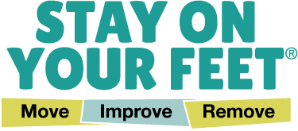

Stay On Your Feet® example survey
Thank you for attending today’s event. You are invited to take part in a short survey.
- What is your age?

p Under 60 p 60-69 p 70-79 p 80-89 p 90 and over

- What is your gender? _____________________

- Do you identify as Aboriginal or Torres Strait Islander?

p Yes p No p Prefer not to say

- Is English your first language?

p Yes p No

If no, what is your primary language spoken? _____________________

- Please rate your agreement with the following statements:
 |   Agree |   Unsure |   Disagree
I think falls can be prevented.
I have increased knowledge of how to remove hazards in and around the home/improve my vision/look after my feet to reduce my risk of having a fall.
I have increased awareness of hazards in and around the home/eye health/foothealth to reduce my risk of having a fall.
I feel motivated to remove hazards in and around the home/get my eyesight checked/wear safe footwear/look after my feet to reduce my risk of having a fall.
This event was relevant to me.
Overall, I was satisfied with the event.
I would like to attend more falls prevention events in the community.

- Why is it important to Remove Hazards? (make your home safer, check your eyesight and wear safe footwear)

- What are three (3) ways you can make your home safe?

- What do you plan on doing or continuing after the program/today to Remove Hazards and reduce your risk of falls?

Thank you for your feedback!

